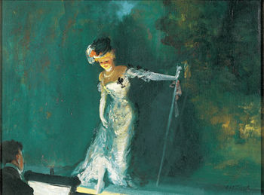
Everett Shinn
Revue - 1908
In the painting "Revue", Everett Shinn shows an actress at the end of her performance. She is bowing politely and has a look of contentment and satisfaction on her face. Shinn was a newspaper illustrator before he turned to painting. This may be the reason for his talent of capturing special moments. In "Revue" the special moment is the ending of a theatrical performance. The bright spotlight against the dark, lonely background emphasizes the actress.

